INSTITUTEOFAERONAUTICALENGINEERING

# (Autonomous)

Dundigal,Hyderabad-500 043

**FieldProject(FP) Report**

# StudentDetails

|  |  |
| --- | --- |
| NameoftheStudent | G.JEEVAN KUMAR |
| RollNumber | 20951A0115 |
| Department | Civil Engineering |
| Year/Semester | II Year, IV semester |
| MobileNumber | 6281108229 |
| EmailID | 20951A0115@iare.ac.in |

1. **MentorDetails**

|  |  |
| --- | --- |
| NameoftheMentor | B Bhavani |
| Organization | Institute of Aeronautical Engineering |
| Designation | Class Incharge |
| EmailID | bbhavani@iare.ac.in |
| MobileNumber | 7674024526 |

# Titleof thefield project

# A Study of a construction site at MADHAPUR,TELAGANA.

1. **Purpose**

* Carry out or oversee the design and construction of a building.
* Ensure safety, stability and cost effectiveness.
* Main responsibilities arechecking designs and overall supervision of site operations.
* Civil engineering also includes other civil infrastructure projects such as water treatment, rail and highway projects, dams, renewable energy projects, etc.

**Objectives:**

# The main objective of our study is to learn about the structural elements like columns, footings, beams, slabs, flooring and etc.

* To produce a structure which is capable to resist all external applied loads without failure during its intended life.
* To obtain the economical dimensions of structural members.
* To investigate the strength, stability and rigidity of structures.
* To ensure structural safety.

**Description of thefield visit**

The subject project is Phase I of a three phase development of a complex located at madhapur Phase I includes construction of 56 apartment units apartment in 7, eight-plex buildings, a separate manager’s unit located above a community building, and a garage/workshop on 155,232 square feet of a 441,530 square foot site. Total gross building area for this phase is calculated as approximately 62,672 square feet. The unit mix includes 32 two-bedroom units with 902 square feet 16three-bedroom units with 1,136 square feet, eight four-bedroom units with 1,336 square feet, and a manager’s three-bedroom unit with 1.336 square feet. The Community Building is listed at 3,300 square feet and the Maintenance/ Garage Building is listed with 308 square feet.

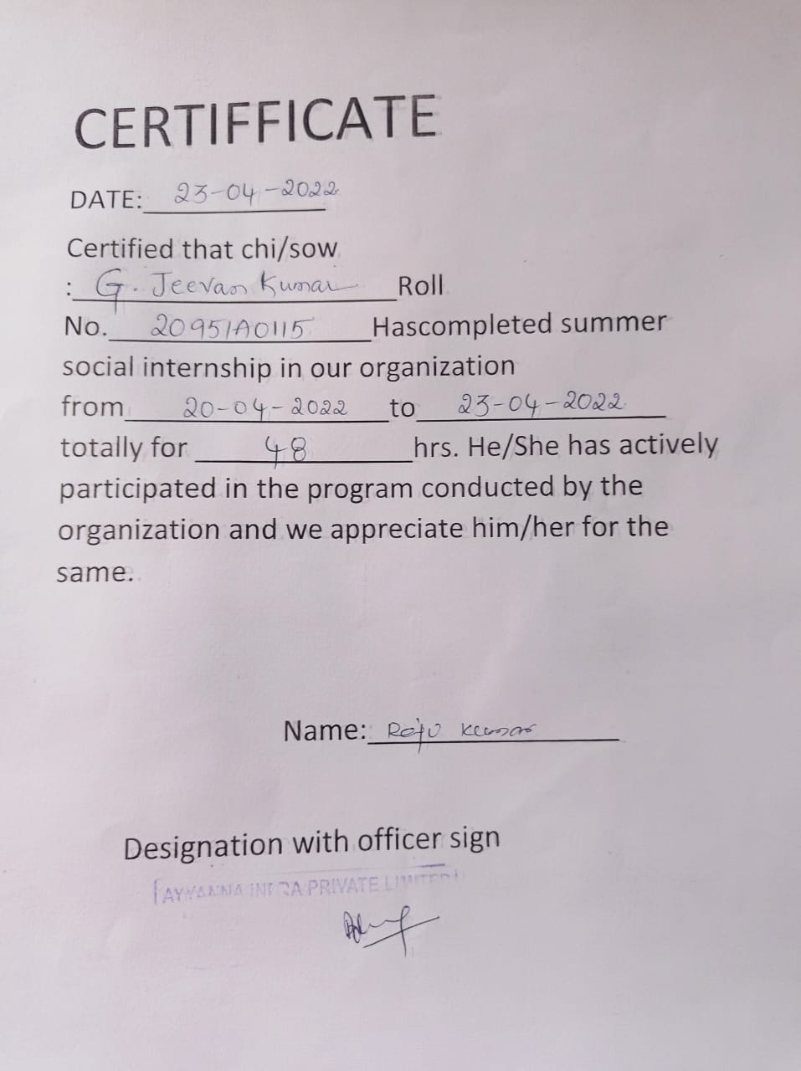

**Introduction:**

The basic components of a building structure are the **foundation, floors, walls, beams, columns, roof, stair,**etc. These elements serve the purpose of supporting, enclosing and protecting the building structure.

Mentioned below are the 7 basic components a building structure.

1. Roof
2. Beams
3. Slabs
4. Columns
5. Floors
6. Stairs
7. Rafting
8. Starters
9. Wall tie
10. Foundation
11. **Roof:**

The roof forms the topmost component of a building structure. It covers the top face of the building. Roofs can be either flat or sloped based on the location and weather conditions of the area.

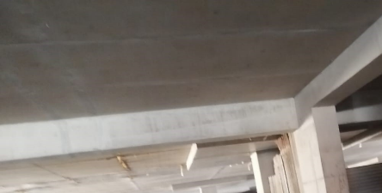

**Fig 1: Roof**

**TYPES OF BEAMS :**

Different types of beams are used in theConstruction of buildings and structures.

These are horizontal structural elements that withstand vertical loads, shear forces,

and bending moments. Beams transfer loads that imposed along their length to

their endpoints such as walls, columns, foundations, etc

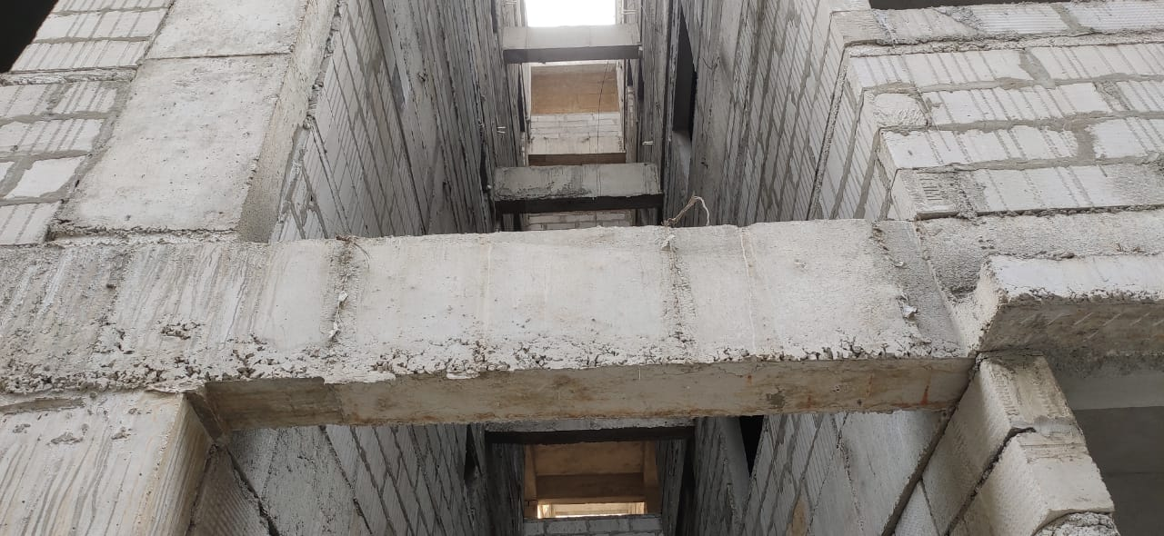

**Fig 2: Beams**

**Types of Beams in Constructions**

1. Simply Supported Beam

2. Fixed Beam

3. Cantilever Beam

4. Continuous Beam

5. Reinforced Concrete Beams

6. Steel Beams

7. Timber beams

8. Composite Beams

9. Rectangular beam

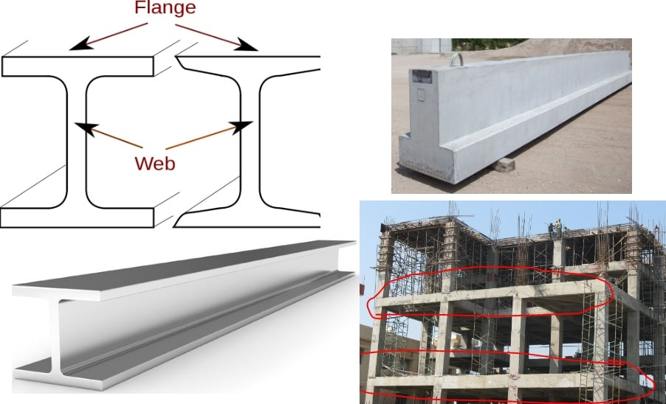

**Fig 3: Different types of Beams**

1. **ConstructionSlabs:**

A slab is a structural element, made of concrete that is used to create flat horizontal surfaces such as floors, roof decks, and ceilings. A slab is generally several inches thick and supported by beams, columns, walls, or the ground.

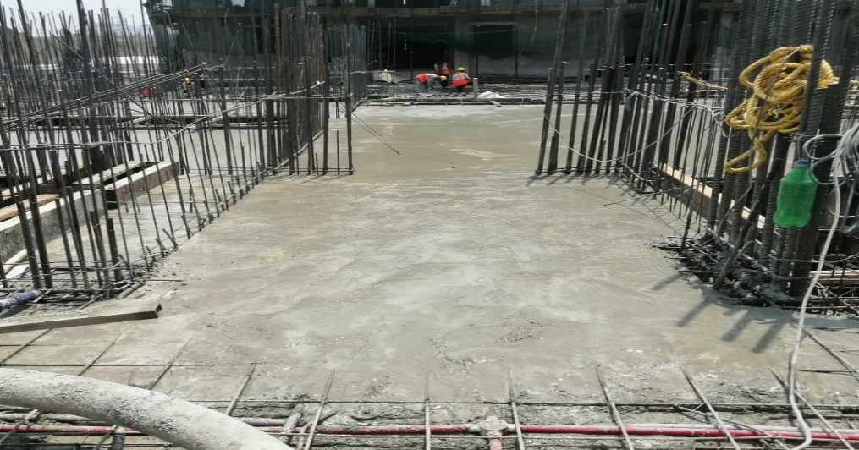

**Fig 4:Slab**

**TYPES OF CEMENT**:

There are various types of cement types used in concrete in construction .Each types of cement has its properties ,uses and advantages based on composition materials used on composition materials used during its manufacture.

1.Ordinary Portland Cement

2.Portland Pozzolana Cement

3.Rapid Hardening Cement

4.Quick Setting Cement

5.Low Heat cement

6.Surface setting cement

7.Blast furnace cement

8.High Alumina cement

9.White cement

10.Colored Cement

11.Air Entraining cement

12.Epansive cement

13.Hydrographic cement

These are the types of cement .But we actually observed at construction site they only using the ordinary Portland cement. We asked the site engineer why you are using only OPC.Cement for construction here and he replied to that is the good quality of cement .setting type is fast and also cheap and best.

**The grade of concrete usage;**

• The grades of concrete they use is M10, M15, M20, M25, M30.

➢ Ready mix concrete

➢ Bathroom sanitary ware

➢ Bathroom fittings

➢ M10 Ready mix concrete

➢ M15 Ready mix concrete

➢ M15 Ready mix concrete

➢ M20 Ready mix concrete

➢ M25 Ready mix concrete

➢ M30 Ready mix concrete.

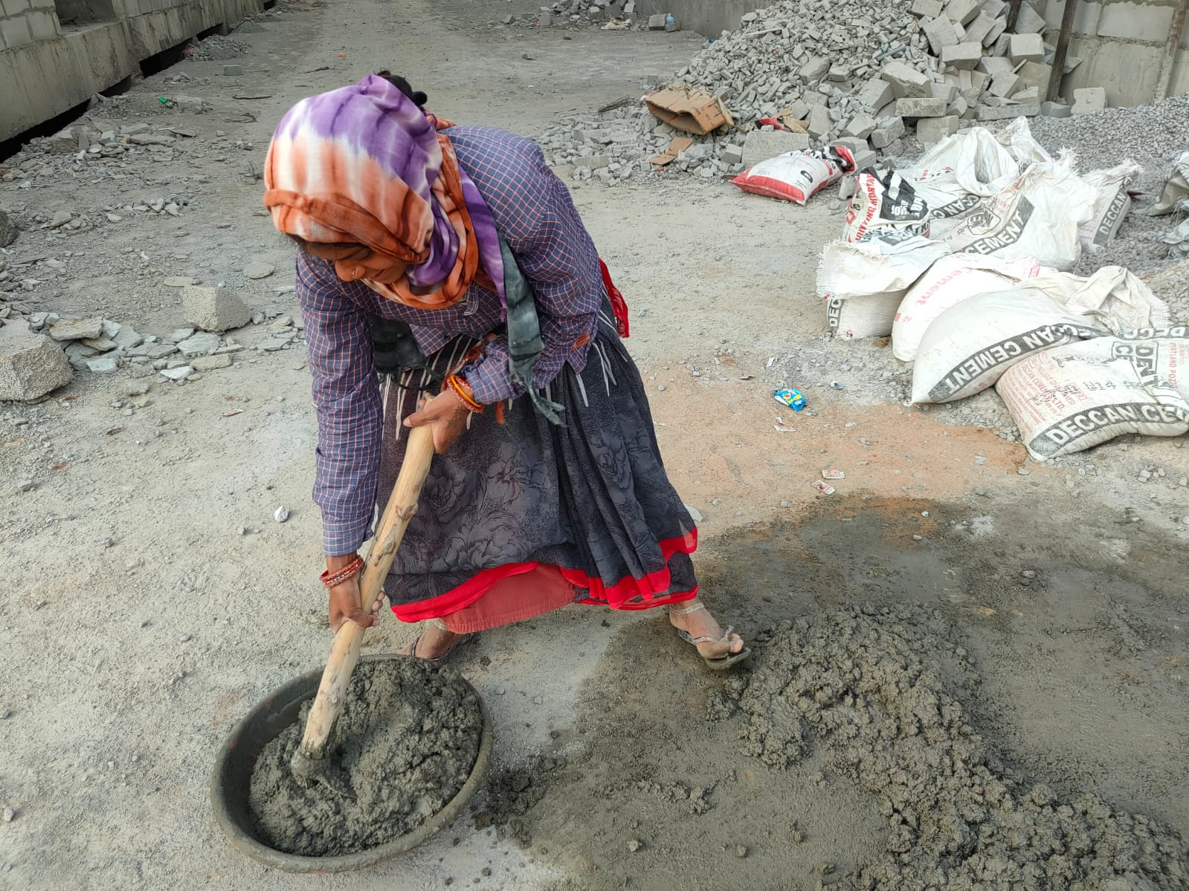

**Fig 5: Mixing of concrete**

• Ready-mix concrete (RMC) is a ready-to-use material with predetermined mixture of cement, sand, aggregates and water. RMC is a type of concrete manufactured in a factory according to the customer specifications. It is delivered to a worksite, often in truck mixers capable of mixing the ingredients of the concrete en route or just before delivery of the batch. And the second option available is to mix the concrete at the batching plant and deliver the mixed concrete to the site in a truck, which keeps the mixed concrete in correct form

Building materials utilize concrete slab-on-grade first floors; conventional wood framed walls, second floors, ceilings, and roof truss structures; Hardie Plank siding, Hardie Shingle siding, Hardie Trim, stucco soffits and wall finishes around patios and second floor decks. Windows are specified to be dual glazed vinyl with low-e glass with an average U-factor of 0.33; and an average SHGC of 0.29. The roof is to be composition shingle with high wind exposure installation.

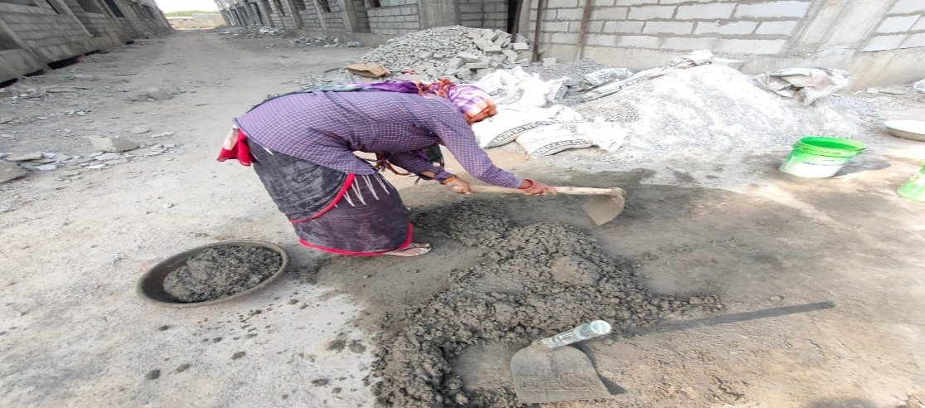

Site development includes earthwork and excavation, fine grading, utility installations, curbing and walkway installations, paving and striping, landscaping, CMU property line walls, and wood enclosure fencing. Utility connections are proposed to connect to existing underground branch locations on the eastern property line. On-grade parking is proposed for120 vehicles, with six spaces designated for the disabled. The proposed development will include a tot lot and an older children’s playground in this first phase of the development. A basketball court is proposed in Phase II of the project. Landscaping at this time appears to be minimal, with most areas designated as “Lawn”.

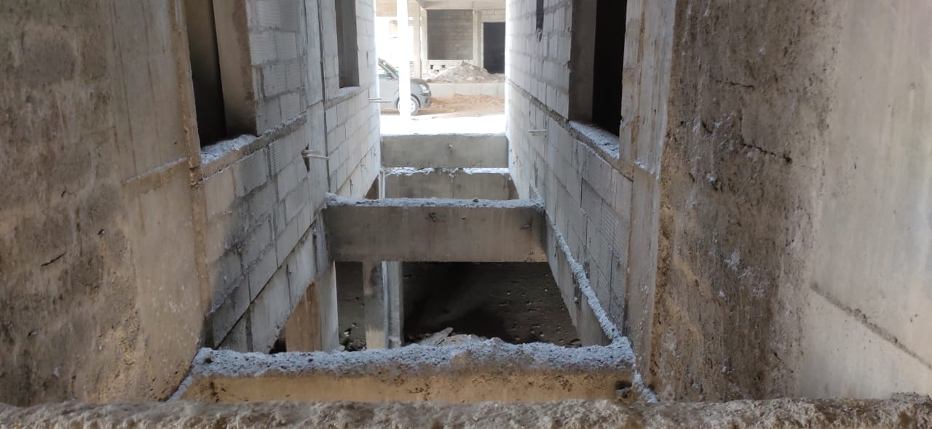

**Fig6 : Inner view of building**

**SITE WORK:**

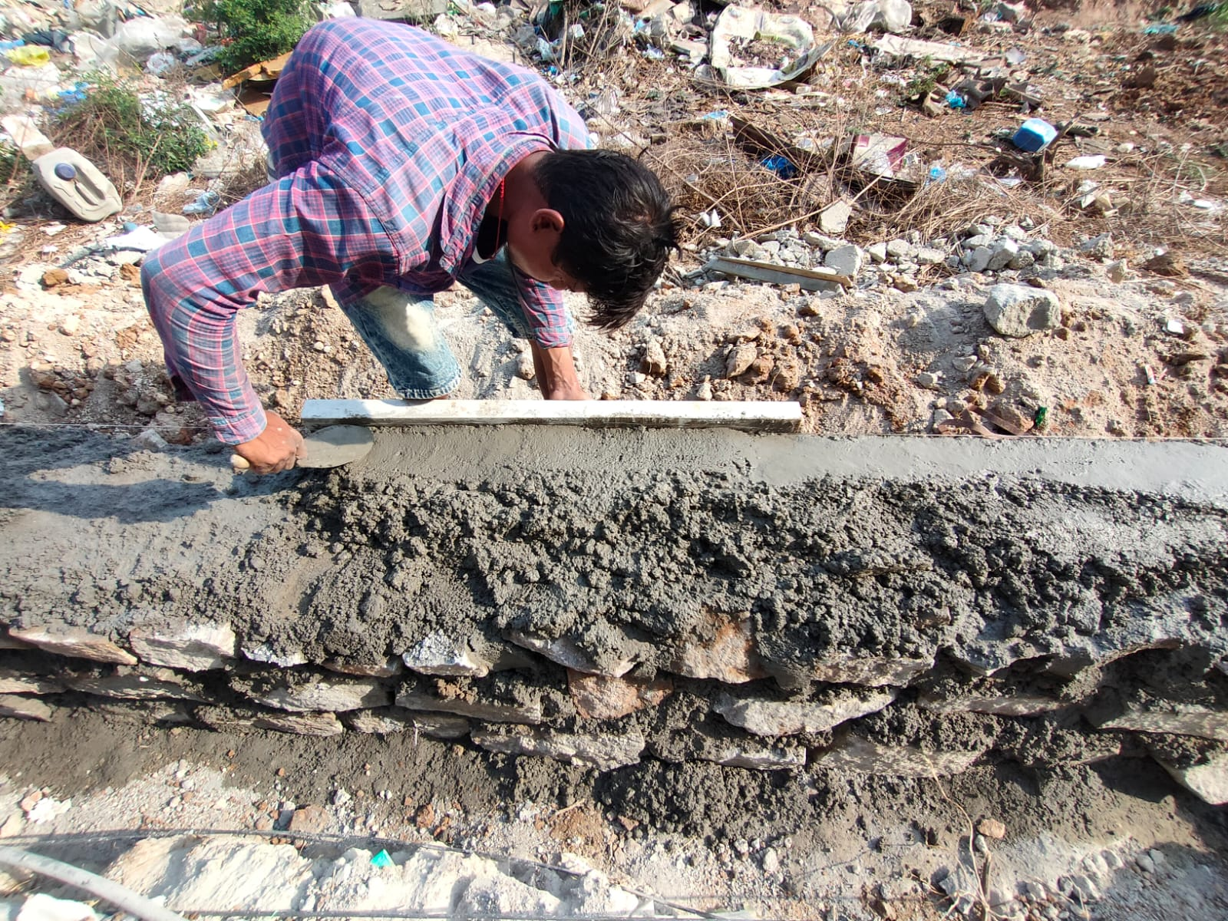The site conditions are predominately moist due to sporadic precipitation; however, access in and around the site and productivity appears relatively unaffected. The main entrance road is graded with stone base in place. Curb and gutter is mostly complete with exception of approximate 50’ sections that tie into number Lane.

Sidewalk is poured at approximately 75% of the south side of the access road. Storm drain and drain inlets are installed. On site access roads and parking areas are rough graded. Curb and gutter forming and pouring is in progress on the north side of the property heading south. Grading around the buildings will require fine grading.

**Fig 7:Plastering**

Underground sanitary and storm sewer lines were tied into the City with all building lateral ties complete. The water main is tied into the City, on site saddle valves, backflows and lateral feeds are stubbed to the buildings. The gas main is tied into the City and lateral stubs to each building complete. Electrical vaults are set and conduits are mostly installed and stubbed into each building. Wet utilities are signed off by the City and dry utilities will reportedly be signed off December in preparation for hardscape and landscaping.

# Working process :

Concrete Building foundations and slabs are poured. .Finish Carpentry No work has been done to date. .Carpentry and Siding .Rough framing is complete at all buildings. Siding is schedule to complete at Building A within the next few days. .Roof and Insulation .Roofing is complete at Buildings B, D, E, F, G and H. Roofing at Building A and C is scheduled to be complete within the next few da

**1**.Windows and Window Coverings ; Exterior windows are installed at all buildings.

.**2.**Finishes and Sheetrock ; No work has been done to date. .Finishes and Paint ; No work has been done to date.

**3**.Finishes Flooring ; No work has been done to date.

**4**.Fire/Sprinkler Alarm ; Fire sprinkler installation is complete at Buildings H and G, and in progress on the first floor .

**5.**Specialty ; No work has been done to date.

**6**.Equipment ; No work has been done to date.

**7**.Cabinets and Countertops ; No work has been done to date.

**8**.Mechanical Plumbing ;; Plumbing waste and vent lines are mostly complete in all buildings. Water lines are complete on the first floor of all buildings and in progress on the second floors. Gas lines are mostly complete at all buildings. Tub enclosures are staged in all units and being set in Building

**9.**H. .Mechanical HVAC ;. Vent line stub outs and condenser line sets are complete at all buildings. .

**10.**Eelectrical; Rough electrical is in progress and in various stages of completion at Buildings A, B and C. Work includes box mounting, wiring, and service panel installation

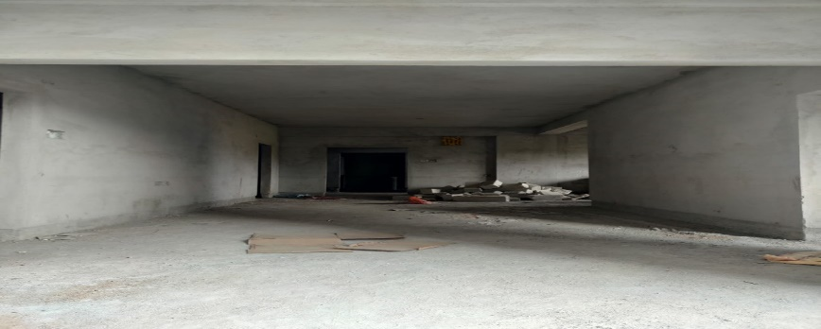

**Fig 8: Structural elements in the buildings**

Engineer’s involvement with this project is limited to a review of the contract documents as contained in the List of Data Received portion of the Plan and Cost Review and subsequent site visits concerning the project status during construction.

The Plan and Cost Review does not constitute a warranty by us or any of our agents, representatives or designees as to the technical sufficiency of adequacy or safety of the structure or any of their component parts, including, without limitation, fixtures, roofing, equipment or furnishings, nor shall such reports or site observations constitute such a warranty as to the sub-soil conditions involved in the project or any other physical condition or feature pertaining to the project. It should be clearly understood that Engineer is not a project manager, project architect, or project supervisor.

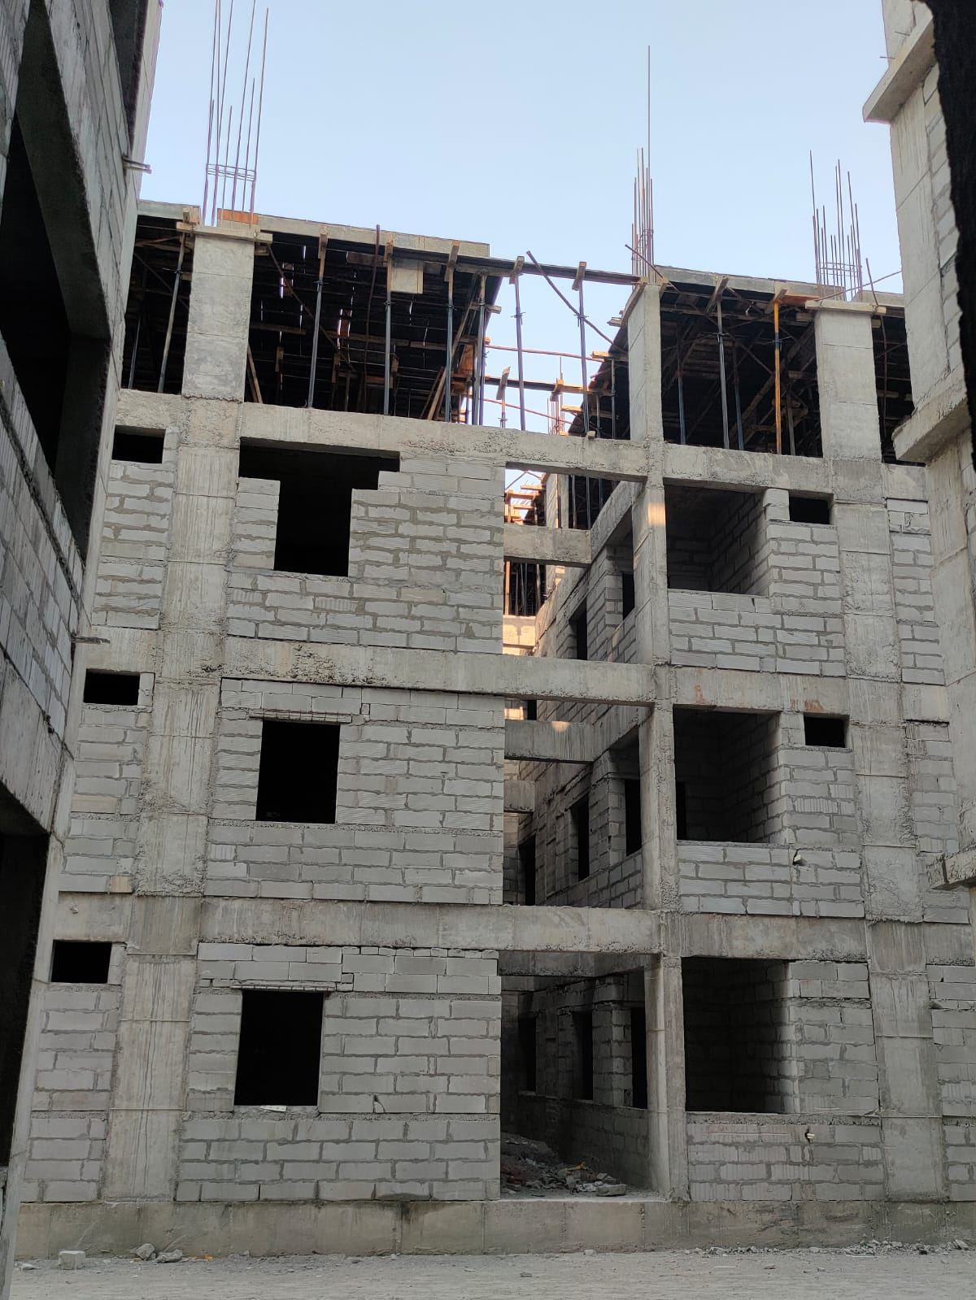 **Fig 9: Front view of the building**

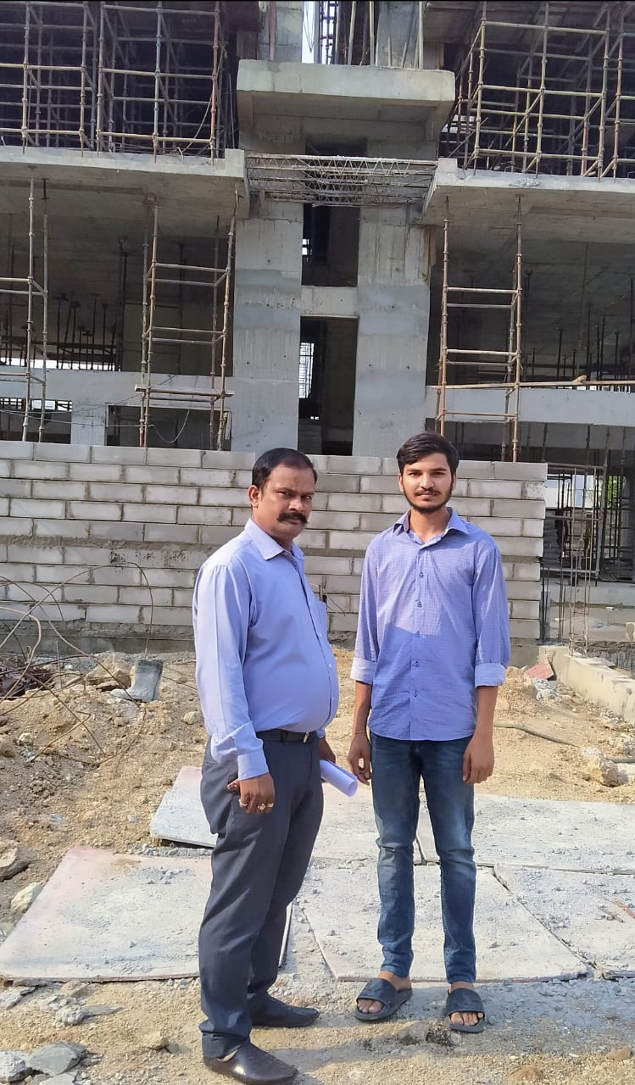

**Fig 10: Interaction with the site Engineer**

